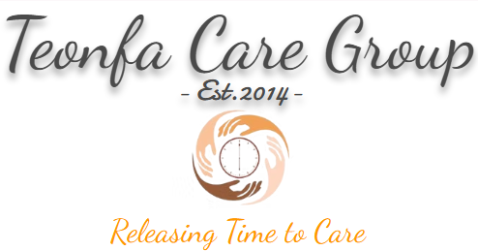

Carbon Reduction Plan – Teonfa Ltd
Publication Date:09/10/2025

Commitment to Achieving Net Zero
Teonfa Ltd is committed to achieving Net Zero greenhouse gas emissions by 2050, in line with the UK Government’s national target and the NHS’s ambition for a Net Zero health and social care system. This commitment reflects our dedication to sustainability, environmental responsibility, and the delivery of high-quality, low-carbon domiciliary and supported living services. This Carbon Reduction Plan will be reviewed and updated annually to reflect progress, changes in operations, and evolving sustainability standards.

Baseline Year: 2010
Our baseline year is 2010, representing Teonfa Ltd’s first full year of operation. Baseline emissions were calculated using the Greenhouse Gas (GHG) Protocol Corporate Accounting and Reporting Standard, covering Scope 1 (direct), Scope 2 (indirect energy), and Scope 3 (other indirect) emissions. Data sources included energy usage, staff travel logs, and waste management estimates.
During the baseline year, Teonfa Ltd:
- Operated from one primary office in Luton, Bedfordshire, with approximately 60 staff delivering domiciliary and supported living care across Bedfordshire and Berkshire.
- Recorded most Scope 3 emissions from business travel and community care mileage.
- Engaged key suppliers, estimated via spend-based methodology to calculate indirect emissions.
- Adjusted for an unusually cold winter (degree-day correction) and excluded non-representative, one-off business events.
- Although overall staffing levels have remained broadly stable, Teonfa Ltd has significantly improved operational efficiency, vehicle performance, and renewable energy use, leading to a genuine decrease in carbon intensity per employee.

Baseline Emissions (tCO₂e)
Scope 1 | 8.21
Scope 2 | 20.543
Scope 3 | 75.17
Total | 103.923

Current Emissions (tCO₂e)
Scope 1 | 4.62
Scope 2 | 12.565
Scope 3 | 25.68
Total | 42.865

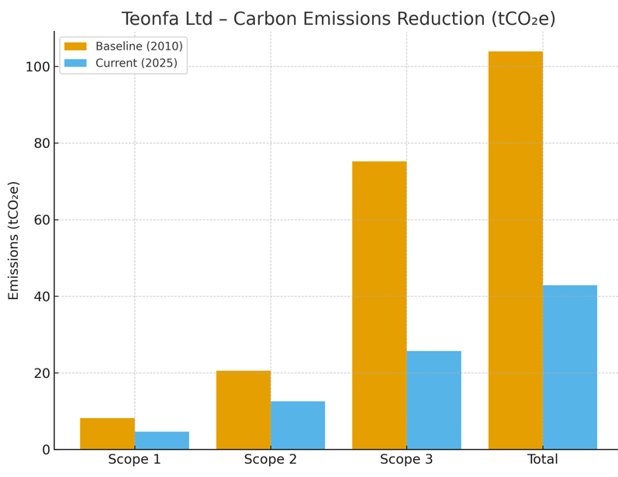

Year | Scope 1 | Scope 2 | Scope 3 | Total | % Reduction vs. Baseline
2010 (Baseline) | 8.21 | 20.543 | 75.17 | 103.923 | —
2025 (Current) | 4.62 | 12.565 | 25.68 | 42.865 | 59%
2035 (Target) | 3.5 | 9.4 | 19.3 | 32.2 | 69%
2050 (Net Zero Goal) | 0 | 0 | 0 | 0 | 100%

Reporting Boundary Clarification
Scopes 1 and 2 cover emissions from Teonfa Ltd’s directly operated facilities, including the main office in Luton. Landlord-managed supported accommodation properties are accounted for under Scope 3, as Teonfa Ltd does not directly control their energy supply. This ensures transparent and accurate boundary setting in line with GHG Protocol guidance. This approach ensures that Teonfa Ltd accounts for all emissions under its direct control while transparently including relevant upstream and downstream impacts within Scope 3 reporting. Monitoring and Performance Tracking Progress against carbon reduction targets is monitored quarterly through internal energy and emissions audits, supported by an ESG tracking spreadsheet that records consumption, fleet mileage, and waste reduction metrics. Annual results are reviewed by senior management to ensure Teonfa Ltd remains on track toward Net Zero.

Emissions Reduction Progress and Targets
Teonfa Ltd has achieved a 59% reduction in total emissions since 2010, primarily through renewable electricity adoption at our main office, energy efficiency measures, and reduced staff travel. Having already exceeded earlier medium-term goals, our new focus is on intensity-based reductions and residual decarbonisation of all Scopes by 2050. Having already achieved a 59% reduction since our 2010 baseline, these future targets now focus on maintaining existing progress while tackling residual emissions from fuel use, grid-dependent accommodation, and supplier activities.
Having already exceeded earlier medium-term goals, our new focus is on measurable, intensity-based reductions and residual decarbonisation of all Scopes by 2050. We aim to reduce Scope 1 and 2 emissions by 10% (equivalent to approximately 4.3 tCO₂e) by 2027 and by 25% (approximately 10.7 tCO₂e) by 2035, using 2025 emissions as the baseline for tracking.

- Short-term (by 2027): Maintain reductions and achieve a further 10% decrease in total emissions intensity.
- Medium-term (by 2035): Achieve a 25% reduction in remaining Scope 1 and Scope 2 emissions.
- Long-term (by 2050): Achieve full Net Zero across all operational and supply chain emissions.

Completed Carbon Reduction Initiatives
- Installed solar panels at the main office, now generating approximately 30% of its electricity.
- Secured 100% renewable electricity for the main office through a green energy contract (REGO-certified). This renewable supply currently applies to our main office. Supported accommodation sites managed by landlords remain on conventional grid supply, which contributes to residual Scope 2 emissions.
- Upgraded all lighting to energy-efficient LED systems, achieving around 20% energy reduction.
- Implemented smart controls for heating and lighting, cutting waste by approximately 15%.
- Introduced comprehensive recycling schemes, reducing landfill waste by over 40%.
- Launched a staff sustainability awareness programme, promoting low-carbon commuting, car-sharing, and ‘cycle-to-work’ participation.
- Updated procurement policies to prioritise environmentally responsible and sustainable suppliers.

Ongoing and Planned Carbon Reduction Projects
- Deploying an advanced energy management system to enable real-time energy monitoring.
- Collaborating with landlords to improve insulation, windows, and heating efficiency at supported accommodation sites.
- Developing a supplier engagement programme focused on reducing Scope 3 emissions.
- Expanding hybrid and electric vehicle use within the company fleet, with charging points installed at premises.
- The reduction in Scope 3 emissions achieved to date has primarily resulted from reduced travel frequency, digital systems for care management, and staff hybrid working. The full impact of fleet electrification will be realised as new vehicles are introduced from 2026 onward.
- Exploring small-scale on-site renewable generation and certified carbon offset projects.
- Implementing a carbon offset strategy focused on UK-based woodland creation and internationally verified carbon standard (VCS) projects, ensuring all offsets are certified and transparently reported as part of Teonfa Ltd’s Net Zero journey.
- Promoting digital administration and hybrid working to reduce commuting emissions.
- Introducing green IT policies, including virtualisation and responsible e-waste disposal.
- Launching a ‘Green Champions’ staff network to encourage sustainability innovation across the organisation.

Declaration and Sign-Off
This Carbon Reduction Plan has been prepared in accordance with PPN 06/21 and its associated guidance, using the GHG Reporting Protocol and aligned with NHS sustainability expectations. It reflects Teonfa Ltd’s ongoing commitment to achieving Net Zero by 2050 and supporting global and local environmental goals.
This plan is fully aligned with NHS England’s Net Zero Supplier Roadmap milestones, supporting the NHS ambition for a Net Zero supply chain by 2030 for direct emissions and by 2045 for indirect emissions.
Signed on behalf of the Supplier:
Name: David Adjarhore ( Nominated Individual/ Director)
Date:09/10/2025

